**Local News Coverage of the Event**

**The Star Beacon**

*[“Veterans Honor Military-Bound High School Students”](https://www.starbeacon.com/news/veterans-honor-military-bound-high-school-students/article_fbe2a502-1460-11ef-b4c6-f72591b973c8.html)*

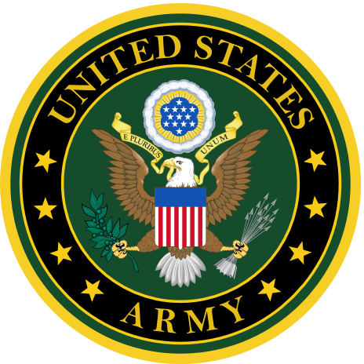 UNITED STATES ARMY 

Quinn Thomas of Lakeside HS  
Martin Rea of Lakeside HS

Sierra Reynolds of Edgewood HS

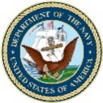 UNITED STATES NAVY 

Liam Marcrom of Geneva HS

Zachary Morgret of Pymatuning Valley HS

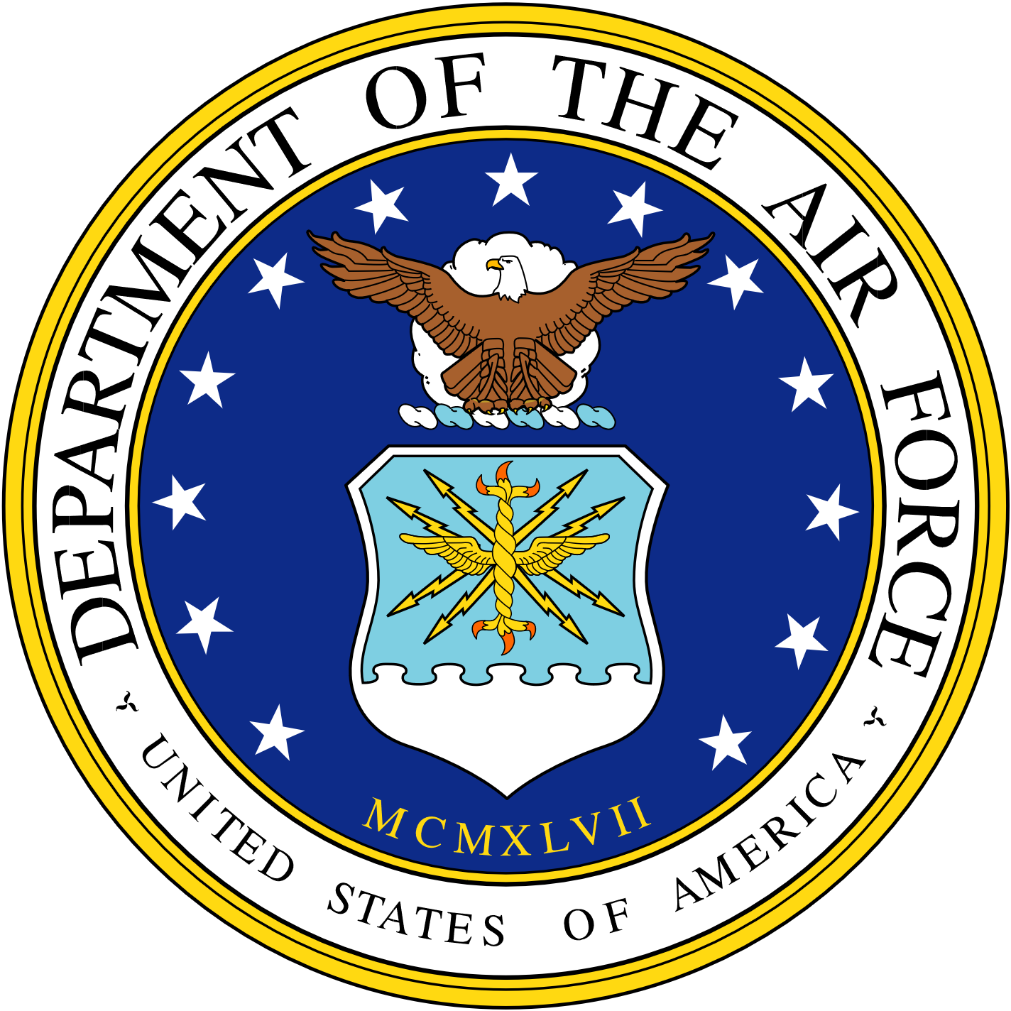 UNITED STATES AIR FORCE 

Andrew Shumate of Edgewood HS  
Patrick Fagan of Edgewood HS  
Ariona Oster of Conneaut HS  
Shawn Jewett of Lakeside HS  
Sara Stone of Jefferson HS