**Local News Coverage of the Event**

**The Star Beacon**

[*“Seniors entering military get community support”*](https://www.starbeacon.com/news/seniors-entering-military-get-community-support/article_fcff3e15-cec6-417e-929a-d4f08f814c0c.html)

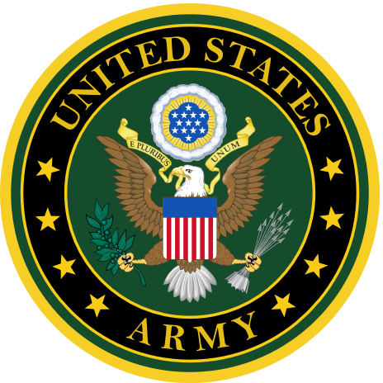 UNITED STATES ARMY 

Makayla Spaid of Edgewood HS  
Alexander Battaglioli of ATECH(Jefferson)  
Landen Coder of Pymatuning Valley HS  
Aiden Farr of Edgewood HS  
Timothy Frabotta of ATECH (Geneva)  
Nicholas Hezebicks of Jefferson HS  
Aidan Burch of Edgewood HS  
Brayden Vatananonh of Edgewood HS  
Chris Skwera of Edgewood HS

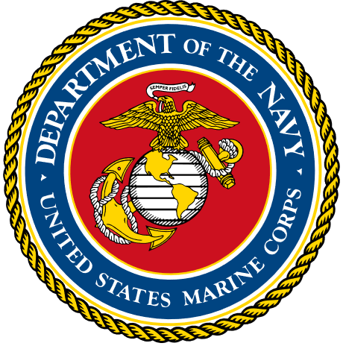 UNITED STATES MARINE CORPS 

Jerrod Addair Jr. of Lakeside HS

Damon Brainard of Pymatuning Valley HS  
Daniel Hutchins of St. John’s HS  
 UNITED STATES NAVY 

Jaiden Ralston of Conneaut HS Colin

Cantrell of ATECH (Geneva)

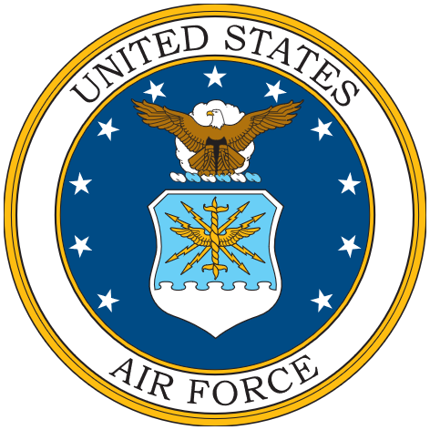 UNITED STATES AIR FORCE   
  
Colin Cantrell of ATECH (Geneva)